A

PROJECT REPORT

On

**“LUCKY SALT SUPPLIER BILLING SYSTEM”**

A MINI PROJECT REPORT SUBMITTED IN PARTIAL FULFILMENT OF

THE

REQUIREMENTS FOR THE AWARD OF DEGREE OF

**BACHELOR OF ENGINEERING**

**(FIFTH SEMESTER)**

**IN**

**COMPUTER SCIENCE & ENGINEERING**

PRESCRIBED BY

**GONDWANA DIGITAL UNIVERSITY, GADCHIROLI**



**DEPARTMENT OF COMPUTER SCIENCE & ENGINEERING**

**GOVERNMENT COLLEGE OF ENGINEERING, CHANDRAPUR**

**(YEAR 2019-20)**

A

PROJECT REPORT

On

**“LUCKY SALT SUPPLIER BILLING SYSTEM”**

A MINI PROJECT REPORT SUBMITTED IN PARTIAL FULFILMENT OF

THE

REQUIREMENTS FOR THE AWARD OF DEGREE OF

**BACHELOR OF ENGINEERING**

**(FIFTH SEMESTER)**

**IN**

**COMPUTER SCIENCE & ENGINEERING**

PRESCRIBED BY

**GONDWANA DIGITAL UNIVERSITY, GADCHIROLI**

SUBMITTEDBY: GUIDED BY:

**Mr. GANESH PALVE PROF. JAYANTI P. CHUBEY**

**Mr. ARBAJ SAIYYED**

**Mr. RITESH KURVE**

**Mr. SANTOSH MAGAR**

**Mr. NIKHIL MOWADE**



**DEPARTMENT OF COMPUTER SCIENCE & ENGINEERING**

**GOVERNMENT COLLEGE OF ENGINEERING, CHANDRAPUR**

**(YEAR 2019-20)**

**CERTIFICATE**

This is to clarify that the project entitled “LUCKY SALT SUPPLIER BILLING SYSTEM” has been carried out by the team under my guidance in partial fulfillment of the Degree of Bachelor of Engineering in Computer Science and Engineering of Gondwana University, Gadchiroli during the academic year 2019-20.

**Team Members:**

**Mr. GANESH PALVE ( T.L. )**

**Mr. ARBAJ SAIYYED**

**Mr. RITESH KURVE**

**Mr. SANTOSH MAGAR**

**Mr. NIKHIL MOWADE**

**Date:**

**Place:** Chandrapur

**Guide Head Of Department**

(Prof. Jayanti P. Chaubey) (Dr. Dilip K. Maghade)

**GOVERNMENT COLLEGE OF ENGINEERING, CHANDRAPUR**

**ACKNOWLEDGEMENT**

With immense pleasure and sense of satisfaction we present the project as part of the curriculum of the Degree in Computer Science & Engineering. We wish to thank all the people to gave us and unending support right from idea was conceived. We are very fortunate to be guided by the vast and resourceful experience in their respective field of work.

We express our sincere gratitude to our guide Prof. Jayanti P. Chaubey for their timely guidance, extensive support and suggestion. We are also thankful for their sincere help in proving facilities of the department.

Our sincere thanks to our HOD Dr. Dilip K. Maghade the teaching and non-teaching staff for the help extended by them for making this project a success.

**Thanking you..!**

**INDEX**

|  |  |  |
| --- | --- | --- |
| **SR. NO.** | **CONTENTS** | **PAGE NO.** |
| 1 | INTRODUCTION  1.1 INTRODUCTION  1.2 PROBLEM FORMULATION | **1**  **1** |
| 2 | DESCRIPTION  2.1 USES  2.2 APPLICATIONS | **2**  **2** |
| 3 | MODULES  3.1 LOGIN  3.2 ABOUT  3.3 PRODUCTS  3.4 PRINT BILL  3.5 UPDATE QUANTITY  3.6 ADD NEW PRODUCTS  3.7 HISTORY  3.8 CONTACT  3.9 LOGOUT | **3**  **3**  **3**  **3**  **3**  **3**  **4**  **4**  **4** |
| 4 | METHODOLOGY  4.1 USECASE DIAGRAM  4.2 FLOWCHART  4.3 DATA FLOW DIAGRAM (DFD)  4.4 ACTIVITY DIAGRAM  4.5 CLASS DIAGRAM  4.6 STATE DIAGRAM | **5**  **6**  **7**  **8**  **9**  **9** |
| 5 | CODING | **10** |
| 6 | SCREENSHOTS | **13** |
| 7 | SYSTEM REQUIREMENTS  7.1 HARDWARE REQUIREMENTS  7.2 SOFTWARE REQUIREMENTS | **17**  **17** |
| 8 | ADVANTAGES AND DISADVANTAGES | **18** |
| 9 | CONCLUSION | **19** |
| 10 | REFERENCES | **20** |

**INTRODUCTION**

**1.1 INTRODUCTION**

The project “Lucky Salt Supplier Billing System” is an application to automate the process of billing of a “Lucky salt supplier store”. This is a web-based application is designed considering the chain of Salt supplier store which is located in various cities. This application only administrates by Admin.

This billing and invoicing system namely “Lucky Salt Supplier Billing System” is used to overcome the entire problem which they are facing currently, and making complete automation of manual billing and invoicing system. In the specifying project we are going to make various modules as Admin Login, View Products, Add to Cart, Billing, View Records. From an end-user perspective, the billing Project consists of enhanced searchable database for customer, products, billing and pricing system.

The system operator will be able to Add, Edit and search the products. Also the operator can delete the product; update the cost of the product as per the rights given to operator by the administrator. Improved search capabilities of products information will be available. It will display all the details of the particular product with current stock

**1.2 PROBLEM FORMULATION**

* The client uses old database system to maintain their product list, customer list, and print the invoice, however it is not possible to store and share the data from multiple systems in multiuser environment.
* There is no option to find and print previous invoice and it can be easily achieved in proposed project
* When the product price is hanged it needs to update each and every excel file.
* There are lots of duplicate works and chances to mistakes.

This billing and invoicing system namely “Lucky Salt Supplier Billing System” is used to overcome the entire problem which they are facing currently, and making complete automation of manual billing and invoicing system.

**DESCRIPTION**

**2.1 USES**

1. To develop an application that deals with the day to day requirement of  any production organization
2. To develop the easy management of the inventory
3. To handle the inventory details like sales details, purchase details and  stock details.
4. To provide competitive advantage to the organization.
5. To provide details information about the stock balance.
6. To make the stock manageable and simplify the use of inventory in the organization.

**2.2 APPLICATIONS**

1. To automate billing of store (salt management).
2. Stock management- tells when it’s time to reorder and how much to purchase.
3. Billing system- generation of invoices easier and faster.
4. Ability of sharing data.
5. Ability of modification of data.
6. User friendly.
7. Supports in decision-making.

**MODULES**

3.1 LOGIN

In this module the admin can login into system by using e-mail and password by providing correctly on login page. In case if provided information is wrong then system will deny the unauthorized access to login.

3.2 ABOUT

In the specified module, the specifications of software are defined and are stating why this software is being made to stock management of various kinds of brands of Salt. The admin can have rights to update inventory and show products purchase details.

3.3 PRODUCTS

All the available products will be enlisted and quantity of the purchase products will be displayed on that module. For purchase of the additional products, the adding of the product will be done as required.

3.4 PRINT BILL

By following the PRODUCTS module, printing of the bill is being carried out using that module. And the bill will be produced in the receipt form for the convenience of the customer.

3.5 UPDATE QUANTITY

As per availability, the quantity of the products available in inventory will be updated by admin by using this module.

3.6 ADD NEW PRODUCTS

Admin can add new products in inventory by using this module. The following details should be filled properly:

* Product Code
* Product Name
* Product Description
* Product Image
* Product Quantity
* Product Price

3.7 HISTORY

All details of purchasing of recent products will be stored on this module. And admin can refer this history for the convenience of customer or himself.

3.8 CONTACTS

The details of the developer(s) of the software are stored on that module for future reference of the user of this software.

3.9 LOGOUT

The logged in admin will go out of the system by using logout module by moving to the login page. And login credentials will be maintaining the security of the sensitive data of the admin.

**METHODOLOGY**

4.1 USECASE DIAGRAM

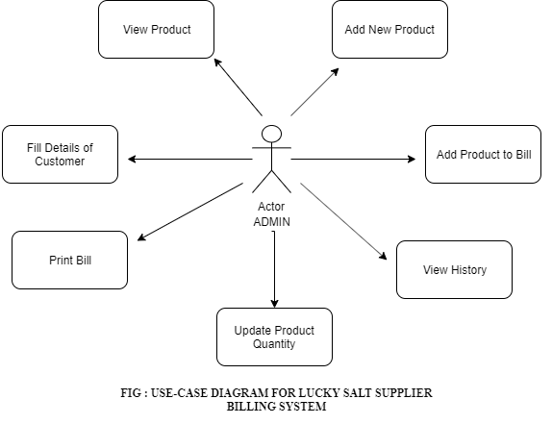

4.2 FLOWCHART

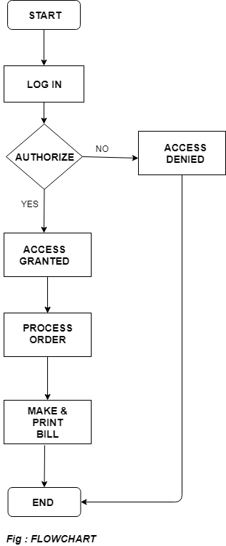

4.3 DATA FLOW DIAGRAM (DFD)

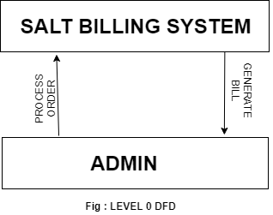

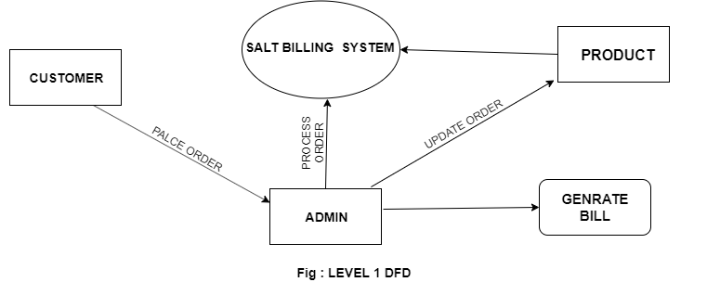

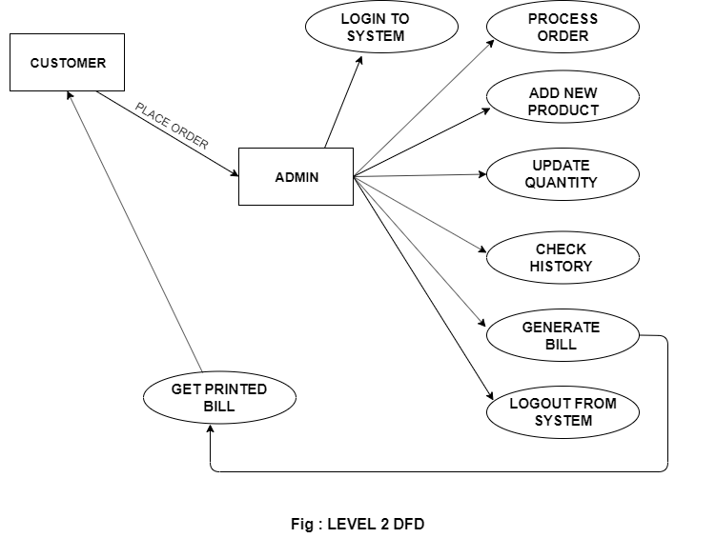

4.4 ACTIVITY DIAGRAM

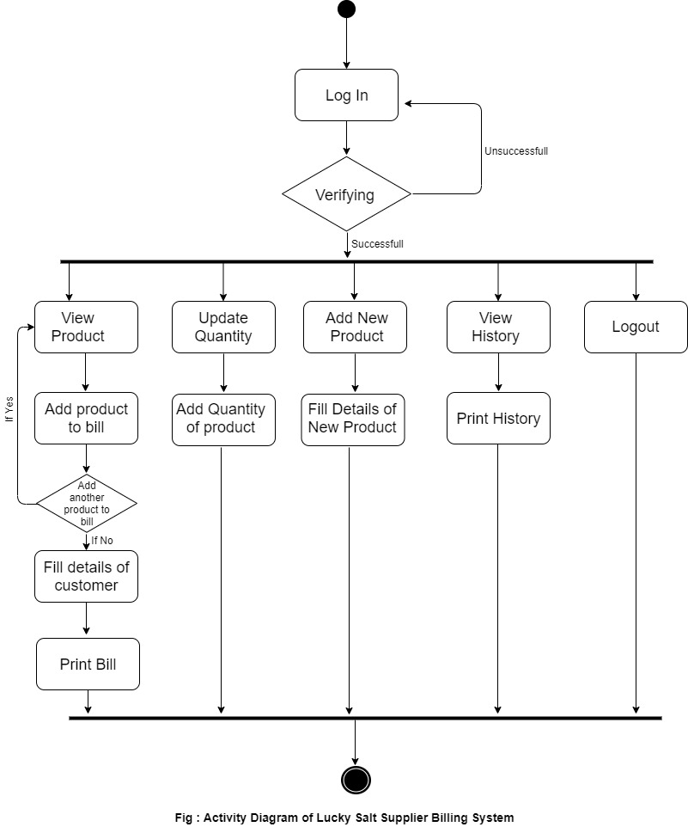

4.5 CLASS DIAGRAM

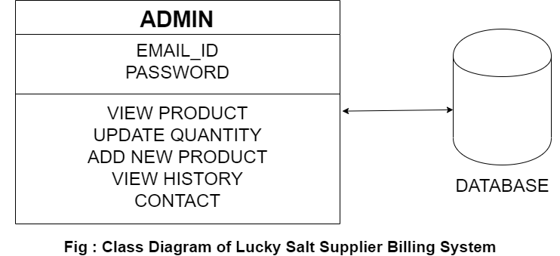

4.6 STATE DIAGRAMS

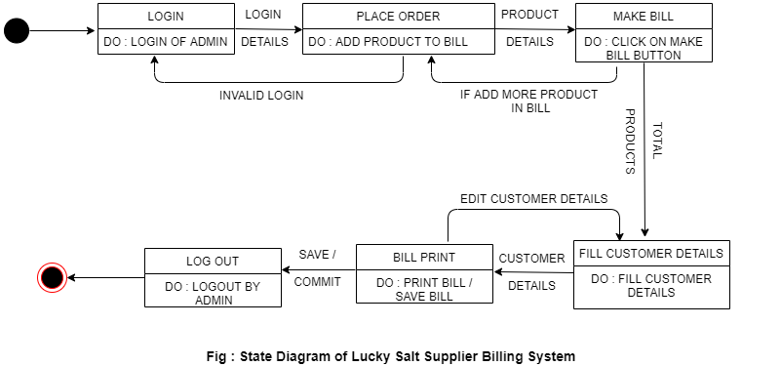

**CODING**

**PRODUCTS MODULE:**

<?php

if(session_id() == '' || !isset($_SESSION)){session_start();}

include 'config.php';

?>

<!doctype html>

<?php include('header.php'); ?>

<body>

<div class="row" style="margin-top:10px;">

<div class="small-12">

<?php

$i=0;

$product_id = array();

$product_quantity = array();

$result = $mysqli->query('SELECT * FROM products');

if($result === FALSE){

die(mysql_error());

}

if($result){

while($obj = $result->fetch_object()) {

echo '<div class="large-4 columns">';

echo '<p><h3>'.$obj->product_name.'</h3></p>';

echo '<img src="images/'.$obj->product_img_name.'"/>';

echo '<p><strong>Product Code</strong>: '.$obj->product_code.'</p>';

echo '<p><strong>Description</strong>: '.$obj->product_desc.'</p>';

echo '<p><strong>Units Available</strong>: '.$obj->qty.'</p>';

echo '<p><strong>Price (Per Unit)</strong>: '.$currency.$obj->price.'</p>';

if($obj->qty > 0){

echo '<p><a href="update-cart.php?action=add&id='.$obj->id.'"><input type="submit" value="ADD" style="clear:both; background: #0078A0; border: none; color: #fff; font-size: 1em; padding: 10px;" /></a></p>';

}

else {

echo 'Out Of Stock!';

}

echo '</div>';

$i++;

}

}

$_SESSION['product_id'] = $product_id;

echo '</div>';

echo '</div>';

?>

<div class="row" style="margin-top:10px;">

<div class="small-12">

<footer style="margin-top:10px;">

<p style="text-align:center; font-size:0.8em;clear:both;"><?php include('footer.php');?></p>

</footer>

</div>

</div>

<script src="js/vendor/jquery.js"></script>

<script src="js/foundation.min.js"></script>

<script>

$(document).foundation();

</script>

</body>

</html>

**SCREENSHOTS**

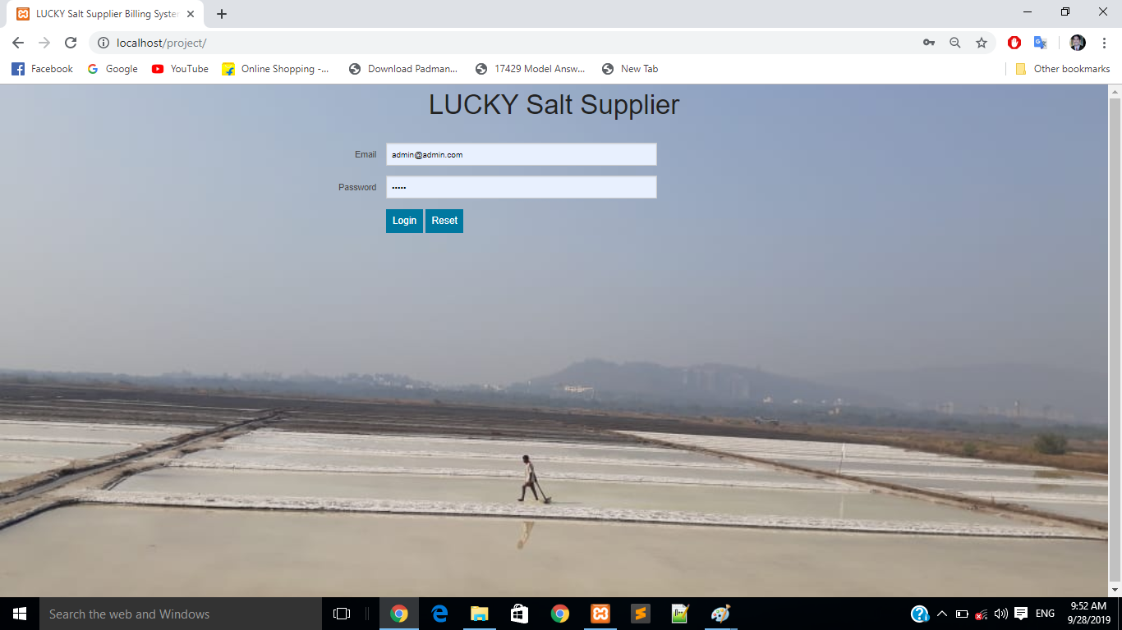

Admin Login

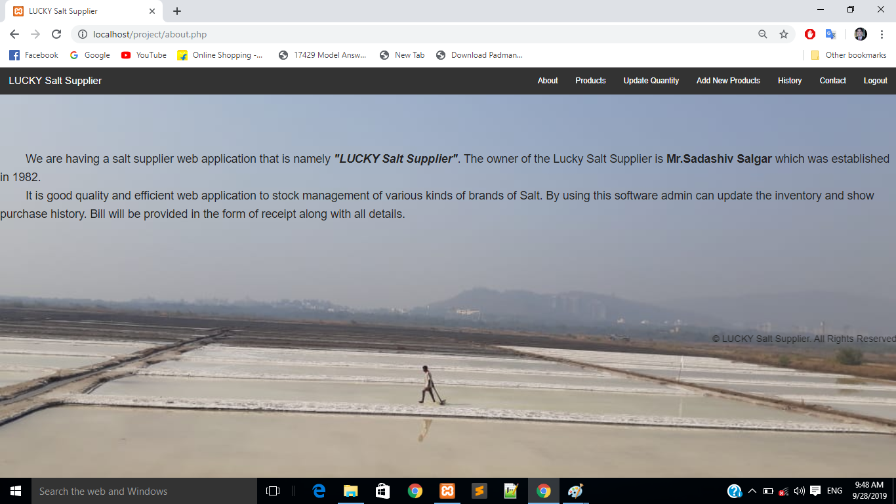

About

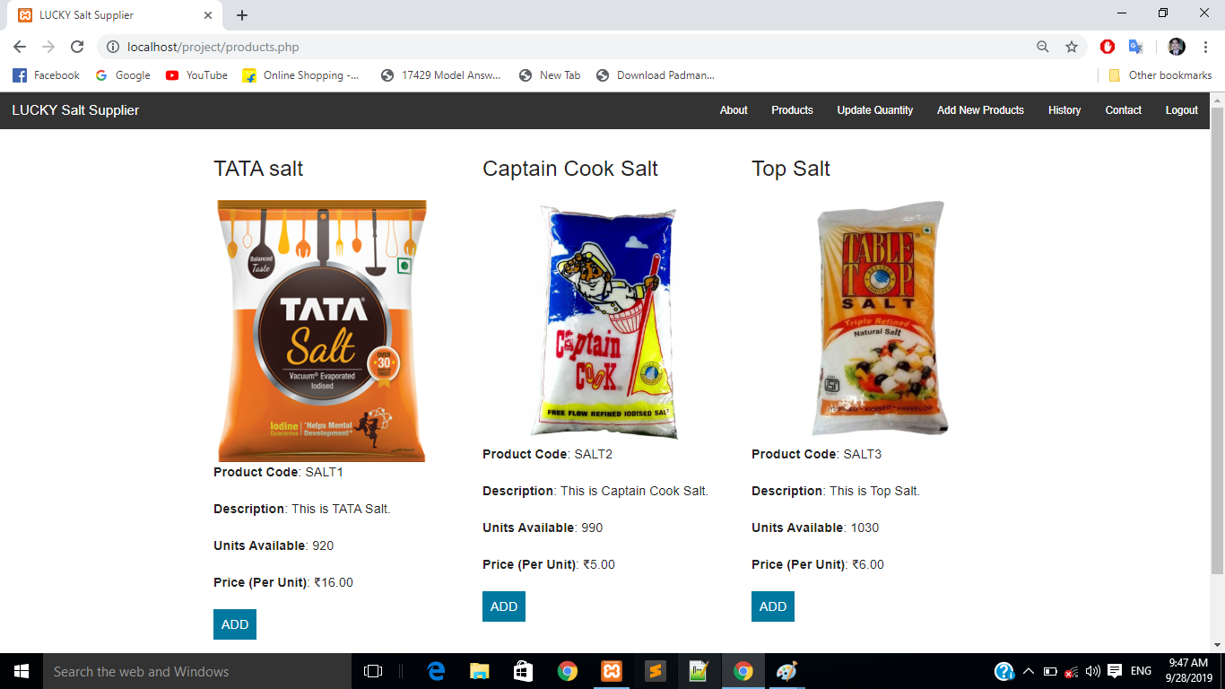

Products

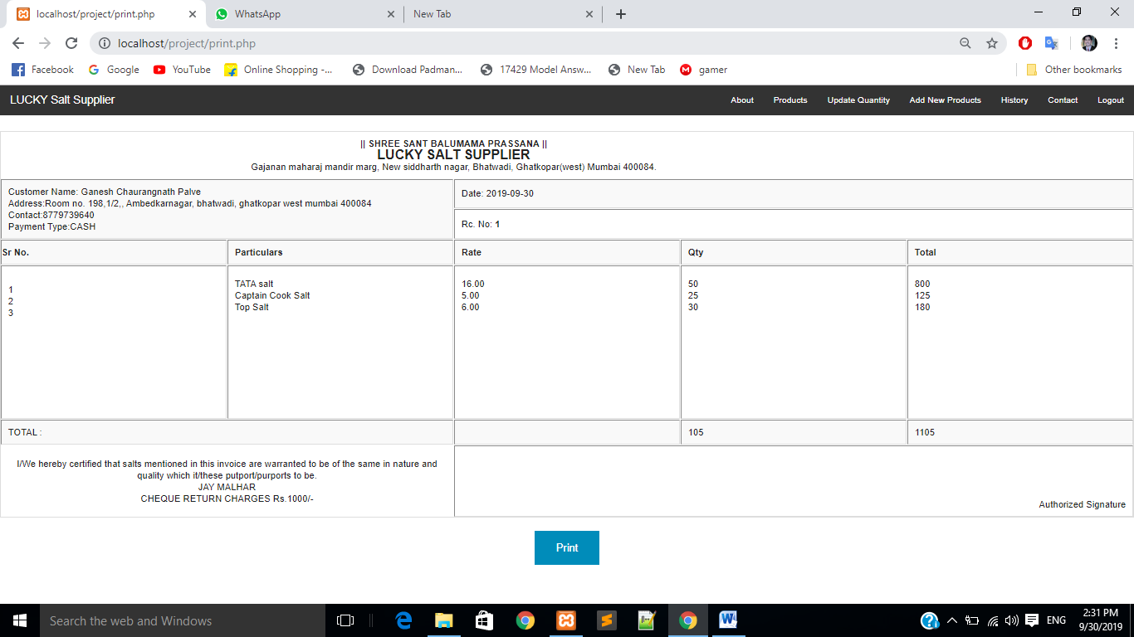

Bill

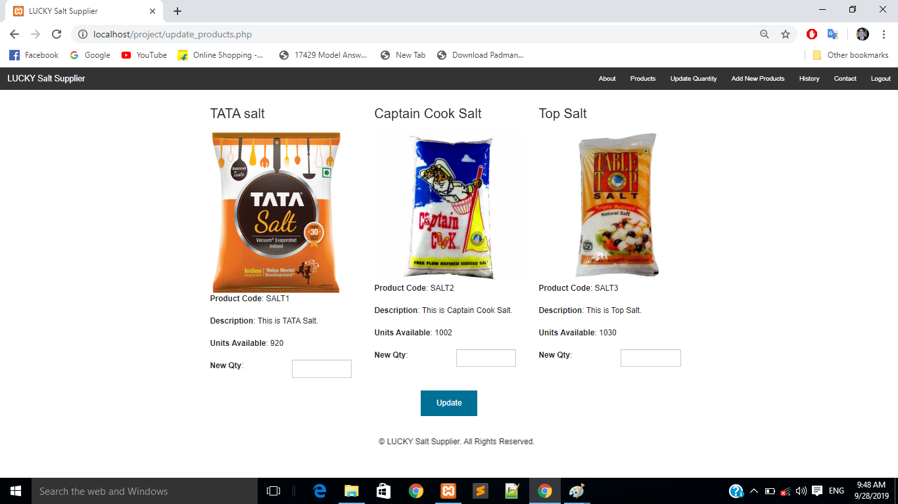

Update Quantity

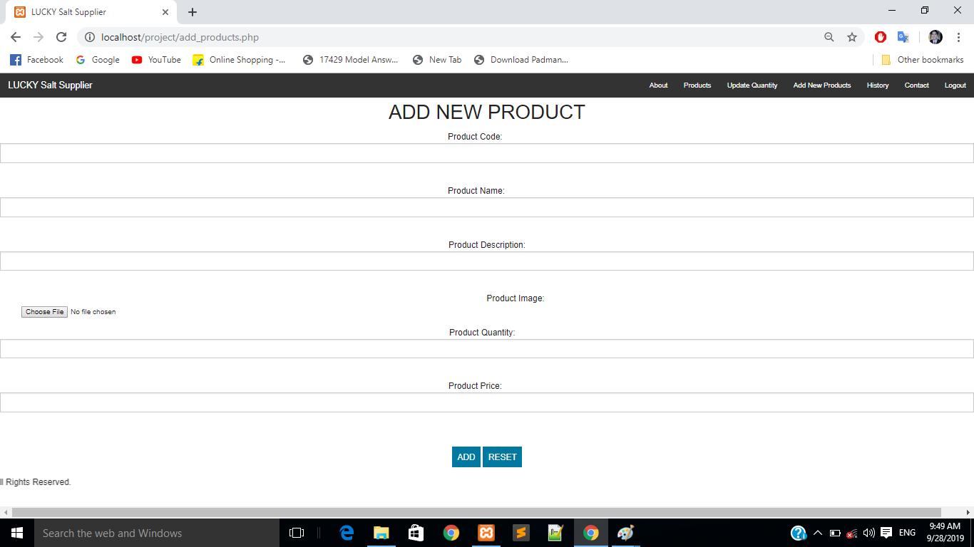

Add New Products

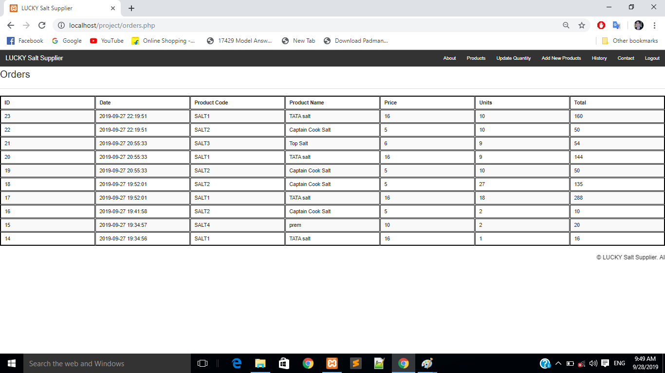

History

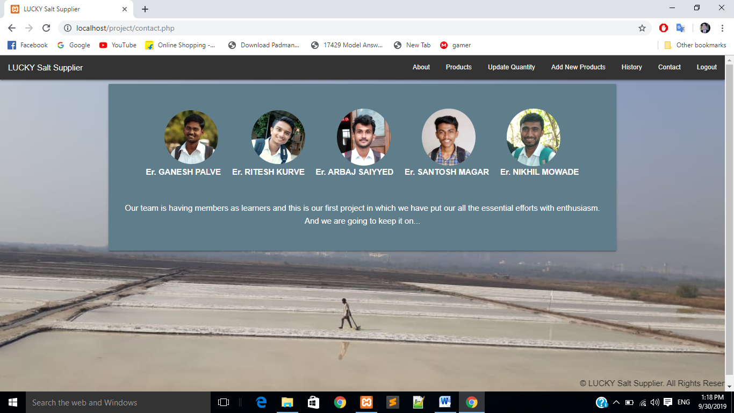

Contact

**SYSTEM REQUIREMENTS**

**7.1 HARDWARE REQUIREMENTS:**

* Processor: Pentium IV
* RAM:512 MB
* Minimum 23GB HDD

**7.2 SOFTWARE REQUIREMENTS:**

* OS: Windows XP onwards.
* XAMPP Server
* Sublime Text Editor
* Web Browser
* Front End: HTML ,CSS, PHP & JavaScript
* Back End: MySql

**ADVANTAGES AND DISADVANTAGES**

**ADVANTAGES:**

1. Manage Subscription Billing.
2. Support Usage Based Billing for IoT.
3. Reduce Administration.
4. Minimize Errors.
5. Integrate Systems.
6. Create Transparency.
7. Simplify Reporting.
8. **Flexibility in billing.**

**DISADVANTAGES:**

1. **May not support cloud based solutions.**
2. Inconvenient to the suppliers at the irregular time periods purchased.

**CONCLUSION**

The proposed project allows end user to login as administrator and management of database for stock management. It processes the customer order and generate bill according to customer specified requirements. At last customer have receipt of bill in both soft copy and hardcopy.

After overall analysis admin can make better decisions for next order placing of stock. Finally, end user will get ease of database management efficiently by using this project.

**REFERENCES**

**BOOK REFERENCE:**

* PHP: The Complete Reference by Steven Holzner.
* PHP: A Beginner’s Guide by Vikram Vaswani.
* HTML & CSS: The Complete Reference by Thomas A. Powell.

**WEB REFERENCE:**

* [www.tutorialspoint.com](http://www.tutorialspoint.com)
* [www.javatpoint.com](http://www.javatpoint.com)
* [www.php.net](http://www.php.net)
* [www.wikipidia.org](http://www.wikipidia.org)
* [www.github.com](http://www.github.com)